Unit 5 – Lesson 2. Weather App Using Online Data
Aim:
- How do we design a weather app using online data?

Objectives: After the lesson, students will be able to:
- Create an Android app using web API

Reference:
https://www.androstock.com/tutorials/create-a-weather-app-on-android-android-studio.html

CLASS PROCEDURE:

Do Now:
Go to the website http://openweathermap.org/, sign up using your school email. In today’s lesson we will use the API provided by the openweathermap to create a weather app.

Presentation / Discussion:

- How do we create the OpenWeatherMap API and get an API key?

  - Sign up an account using your school email
  - Navigate to API
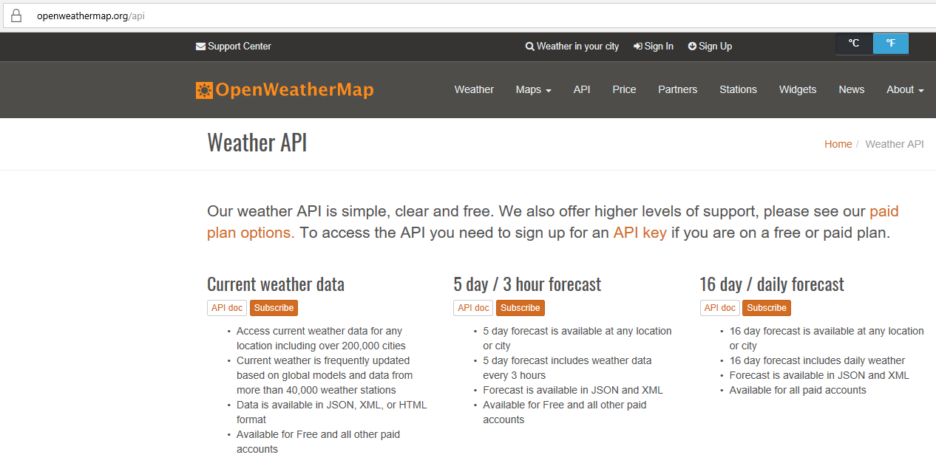

  - Choose one of the API you would like to use, for an example, the Current weather data, and then click on Subscribe (don’t worry we will use the free plan)

  - On the Subscription page (shown on the screen snapshot), choose the free plan and the click on “Get API Key and Start”
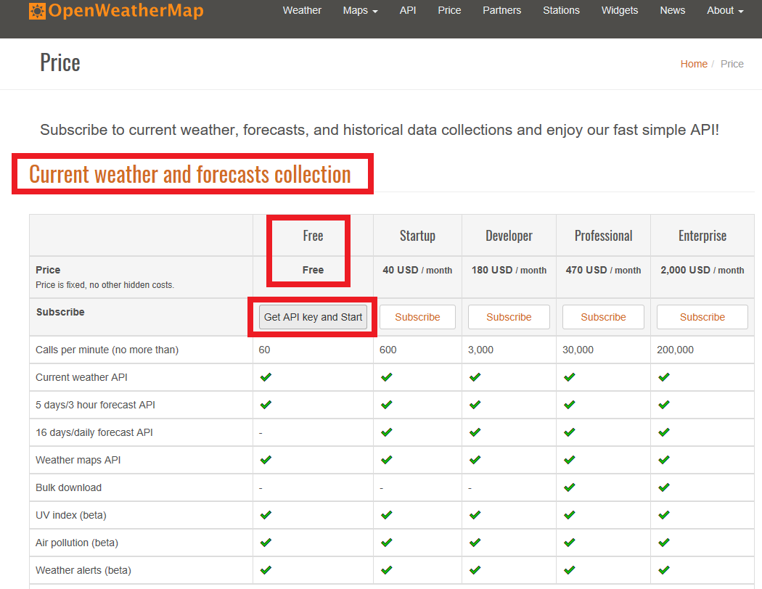

  - After click on Get API Key and Start, go back to the Sign Up screen where you are logged in, and then choose API keys to view your API key. You can create as many keys as you want.

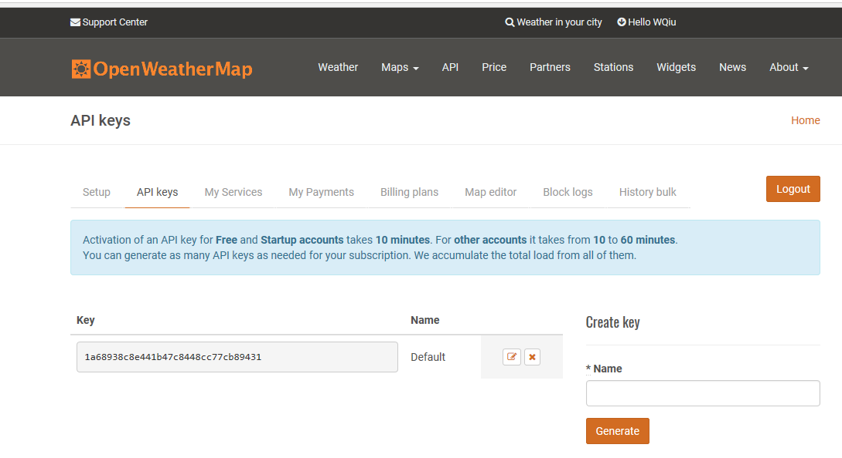
- How do we use the API key and the API in our app?

  - Add permission to access the INTERNET in the manifest.xml

  - Create a layout file just like what we have been doing for all other apps
  - In the Java activity files,
    - we can use the HttpURLConnection class to make the remote request. The OpenWeatherMap API expects the API key in an HTTP header named x-api-key. This is specified in our request using the setRequestProperty method.
    - We use a BufferedReader to read the API’s response into a StringBuffer. When we have the complete response, we convert it to a JSONObject object.

Pair – sharing Activity / Class Activity (Source: https://www.androstock.com/tutorials/create-a-weather-app-on-android-android-studio.html)

1. First of all create a Weather API from OpenWeatherMap.
2. Create a new project in Android Studio in a normal way.
3. Copy weathericons-regular-webfont.ttf to your project’s src/main/assets/fonts directory. You can download the font from here.
4. Open your AndroidManifest.xml file and add internet connect permission. Your manifest file will look like this-
<?xml version="1.0" encoding="utf-8"?>
<manifest xmlns:android="http://schemas.android.com/apk/res/android"
package="com.androstock.myweatherapp" >

<uses-permission android:name="android.permission.INTERNET"/>

<application
android:allowBackup="true"
android:icon="@mipmap/ic_launcher"
android:label="@string/app_name"
android:theme="@style/AppTheme" >
<activity
android:name=".MainActivity"
android:label="@string/app_name" >
<intent-filter>
<action android:name="android.intent.action.MAIN" />

<category android:name="android.intent.category.LAUNCHER" />
</intent-filter>
</activity>
</application>

</manifest>
5. Open your activity_main.xml file. Use a RelativeLayout to arrange the text views. You can adjust the textSize to suit various devices.
<RelativeLayout xmlns:android="http://schemas.android.com/apk/res/android"
xmlns:tools="http://schemas.android.com/tools"
android:layout_width="match_parent"
android:layout_height="match_parent"
android:background="#3F51B5"
android:padding="20dp">

<TextView
android:id="@+id/city_field"
android:layout_width="wrap_content"
android:layout_height="wrap_content"
android:layout_alignParentTop="true"
android:layout_centerHorizontal="true"
android:textColor="#FFFFFF"
android:textAppearance="?android:attr/textAppearanceLarge" />

<TextView
android:id="@+id/updated_field"
android:layout_width="wrap_content"
android:layout_height="wrap_content"
android:layout_below="@+id/city_field"
android:layout_centerHorizontal="true"
android:textColor="#FFFFFF"
android:textAppearance="?android:attr/textAppearanceMedium"
android:textSize="13sp" />

<TextView
android:id="@+id/weather_icon"
android:layout_width="wrap_content"
android:layout_height="wrap_content"
android:layout_centerVertical="true"
android:layout_centerHorizontal="true"
android:textColor="#FFFFFF"
android:textAppearance="?android:attr/textAppearanceLarge"
android:textSize="90sp"
/>

<TextView
android:id="@+id/current_temperature_field"
android:layout_width="wrap_content"
android:layout_height="wrap_content"
android:layout_alignParentBottom="true"
android:layout_centerHorizontal="true"
android:textColor="#FFFFFF"
android:textAppearance="?android:attr/textAppearanceLarge"
android:textSize="50sp" />

<TextView
android:id="@+id/details_field"
android:layout_width="wrap_content"
android:layout_height="wrap_content"
android:layout_below="@+id/weather_icon"
android:layout_centerHorizontal="true"
android:textColor="#FFFFFF"
android:textAppearance="?android:attr/textAppearanceMedium"
/>
<TextView
android:id="@+id/humidity_field"
android:layout_width="wrap_content"
android:layout_height="wrap_content"
android:layout_below="@+id/details_field"
android:layout_centerHorizontal="true"
android:textColor="#FFFFFF"
android:textAppearance="?android:attr/textAppearanceMedium"
/>
<TextView
android:id="@+id/pressure_field"
android:layout_width="wrap_content"
android:layout_height="wrap_content"
android:layout_below="@+id/humidity_field"
android:layout_centerHorizontal="true"
android:textColor="#FFFFFF"
android:textAppearance="?android:attr/textAppearanceMedium"
/>

</RelativeLayout>

6. Now we are going to create a Java class file named Function.java. Here we will write all our functions so that we can use them easily from MainActiviy.java letter.
We use the HttpURLConnection class to make the remote request. The OpenWeatherMap API expects the API key in an HTTP header named x-api-key. This is specified in our request using the setRequestProperty method.
We use a BufferedReader to read the API’s response into a StringBuffer. When we have the complete response, we convert it to a JSONObject object.
package com.androstock.myweatherapp;

import android.os.AsyncTask;
import android.util.Log;

import org.json.JSONException;
import org.json.JSONObject;

import java.io.BufferedReader;
import java.io.InputStreamReader;
import java.net.HttpURLConnection;
import java.net.URL;
import java.text.DateFormat;
import java.util.Date;
import java.util.Locale;

public class Function {

// Project Created by Ferdousur Rahman Shajib
// www.androstock.com

private static final String OPEN_WEATHER_MAP_URL =
"http://api.openweathermap.org/data/2.5/weather?lat=%s&lon=%s&units=metric";

private static final String OPEN_WEATHER_MAP_API = "====== YOUR OPEN WEATHER MAP API ======";

public static String setWeatherIcon(int actualId, long sunrise, long sunset){
int id = actualId / 100;
String icon = "";
if(actualId == 800){
long currentTime = new Date().getTime();
if(currentTime>=sunrise && currentTime<sunset) {
icon = "&#xf00d;";
} else {
icon = "&#xf02e;";
}
} else {
switch(id) {
case 2 : icon = "&#xf01e;";
break;
case 3 : icon = "&#xf01c;";
break;
case 7 : icon = "&#xf014;";
break;
case 8 : icon = "&#xf013;";
break;
case 6 : icon = "&#xf01b;";
break;
case 5 : icon = "&#xf019;";
break;
}
}
return icon;
}

public interface AsyncResponse {

void processFinish(String output1, String output2, String output3, String output4, String output5, String output6, String output7, String output8);
}

public static class placeIdTask extends AsyncTask<String, Void, JSONObject> {

public AsyncResponse delegate = null;//Call back interface

public placeIdTask(AsyncResponse asyncResponse) {
delegate = asyncResponse;//Assigning call back interfacethrough constructor
}

@Override
protected JSONObject doInBackground(String... params) {

JSONObject jsonWeather = null;
try {
jsonWeather = getWeatherJSON(params[0], params[1]);
} catch (Exception e) {
Log.d("Error", "Cannot process JSON results", e);
}

return jsonWeather;
}

@Override
protected void onPostExecute(JSONObject json) {
try {
if(json != null){
JSONObject details = json.getJSONArray("weather").getJSONObject(0);
JSONObject main = json.getJSONObject("main");
DateFormat df = DateFormat.getDateTimeInstance();

String city = json.getString("name").toUpperCase(Locale.US) + ", " + json.getJSONObject("sys").getString("country");
String description = details.getString("description").toUpperCase(Locale.US);
String temperature = String.format("%.2f", main.getDouble("temp"))+ "°";
String humidity = main.getString("humidity") + "%";
String pressure = main.getString("pressure") + " hPa";
String updatedOn = df.format(new Date(json.getLong("dt")*1000));
String iconText = setWeatherIcon(details.getInt("id"),
json.getJSONObject("sys").getLong("sunrise") * 1000,
json.getJSONObject("sys").getLong("sunset") * 1000);

delegate.processFinish(city, description, temperature, humidity, pressure, updatedOn, iconText, ""+ (json.getJSONObject("sys").getLong("sunrise") * 1000));

}
} catch (JSONException e) {
//Log.e(LOG_TAG, "Cannot process JSON results", e);
}

}
}

public static JSONObject getWeatherJSON(String lat, String lon){
try {
URL url = new URL(String.format(OPEN_WEATHER_MAP_URL, lat, lon));
HttpURLConnection connection =
(HttpURLConnection)url.openConnection();

connection.addRequestProperty("x-api-key", OPEN_WEATHER_MAP_API);

BufferedReader reader = new BufferedReader(
new InputStreamReader(connection.getInputStream()));

StringBuffer json = new StringBuffer(1024);
String tmp="";
while((tmp=reader.readLine())!=null)
json.append(tmp).append("\n");
reader.close();

JSONObject data = new JSONObject(json.toString());

// This value will be 404 if the request was not
// successful
if(data.getInt("cod") != 200){
return null;
}

return data;
}catch(Exception e){
return null;
}
}

}
Don’t forget to use your own API Key in the following line.
private static final String OPEN_WEATHER_MAP_API = "====== YOUR OPEN WEATHER MAP API ======";

7. Now time to move towards the MainActivity.java class. We are going to make the activity fullscreen. So add the following line before your setContentView().
getSupportActionBar().hide();
Your MainActivity.java will look like-
package com.androstock.myweatherapp;

import android.graphics.Typeface;
import android.os.Bundle;
import android.support.v7.app.AppCompatActivity;
import android.text.Html;
import android.widget.TextView;

public class MainActivity extends AppCompatActivity {

// Project Created by Ferdousur Rahman Shajib
// www.androstock.com

TextView cityField, detailsField, currentTemperatureField, humidity_field, pressure_field, weatherIcon, updatedField;

Typeface weatherFont;

@Override
protected void onCreate(Bundle savedInstanceState) {
super.onCreate(savedInstanceState);
getSupportActionBar().hide();
setContentView(R.layout.activity_main);

weatherFont = Typeface.createFromAsset(getAssets(), "fonts/weathericons-regular-webfont.ttf");

cityField = (TextView)findViewById(R.id.city_field);
updatedField = (TextView)findViewById(R.id.updated_field);
detailsField = (TextView)findViewById(R.id.details_field);
currentTemperatureField = (TextView)findViewById(R.id.current_temperature_field);
humidity_field = (TextView)findViewById(R.id.humidity_field);
pressure_field = (TextView)findViewById(R.id.pressure_field);
weatherIcon = (TextView)findViewById(R.id.weather_icon);
weatherIcon.setTypeface(weatherFont);

Function.placeIdTask asyncTask =new Function.placeIdTask(new Function.AsyncResponse() {
public void processFinish(String weather_city, String weather_description, String weather_temperature, String weather_humidity, String weather_pressure, String weather_updatedOn, String weather_iconText, String sun_rise) {

cityField.setText(weather_city);
updatedField.setText(weather_updatedOn);
detailsField.setText(weather_description);
currentTemperatureField.setText(weather_temperature);
humidity_field.setText("Humidity: "+weather_humidity);
pressure_field.setText("Pressure: "+weather_pressure);
weatherIcon.setText(Html.fromHtml(weather_iconText));

}
});
asyncTask.execute("25.180000", "89.530000"); // asyncTask.execute("Latitude", "Longitude")

}

}
Save and run the app project.

Pair – sharing Activity / HW:

For your midyear project, you and your partner (up to three people) will design an Android App that uses web online data. You may design the app for some student club, your peer Bronx Science students, your teachers or for some non – profit organization.

Here are the requirements:

- Your app project must be useful and can help people improve their working process, work efficiency or some aspect in their lives

- Your app project design must be user friendly

- Your app project must use some web data (request / retrieve data from online source, and/or send data to online DB or update online document)

- Your app must use data queries to perform any data processing, data mining and/or data modeling

App Design Document is due on Monday, December 4th.

